TAKEN FOR A R.I.D.E.

Testing Deceptions that Harm the Most Vulnerable the Most

By
David V. Anderson
Asora Education Enterprises

One of the most important activities of government is that of ensuring an education for our children. Our government-operated public school systems have been the primary means for meeting this responsibility. Surely, they run the schools, but do they really educate our children to an acceptable degree?

Many government and community leaders, going back for many years, have seen the importance of keeping tabs on the schools by means of assessments. Here in Rhode Island the Rhode Island Department of Education (RIDE) administers the NECAP tests, which provide some of this feedback. Unfortunately, the NECAP tends to exaggerate or inflate student performance. Beyond diagnosing ignorance it is also a vehicle for hiding it.

We earlier wrote about a peculiar phenomenon wherein the NECAP manages to show improving 8th grade reading skills when the more trusted national test- the Nation’s Report Card or NAEP- shows them declining. The reaction from Rhode Island officials, high and low, was to ignore the feedback and in one instance try to “censor” its release to the newspapers. One sees a continued effort to misrepresent Rhode Island students’ skills despite knowing better.

In our research studying schools in Rhode Island and several other states, one of our activities has been making estimates of NAEP proficiencies for local schools and districts, by means of mathematical mapping techniques. We effectively take the exaggerated or inflated academic proficiency percentages reported by the states and then “squeeze” the inflation out of them until we’re left with something more realistic.

The dirty word in this business is “inflation.” Public schools have been struggling for decades to produce well-educated and skilled graduates and by many measures, including the impressions their graduates make as job applicants to employers, they have largely failed. Diplomas from Rhode Island public schools are generally a fraud in that they attest to the achievement of skills nowhere near the actual attainments of most students. Likewise, the NECAP is used to further deceive the public, including parents, children, employers and sometimes the teachers, about the academic skills possessed by public school pupils.

So what is the amount of inflation in Rhode Island you ask? The answer, as is so often the case, is: “It depends.” If you’re a parent with children in one of the better schools, the inflation is less- perhaps because it takes less of it to make your school look good. At the other extreme, horrible schools are made to look barely tolerable by giving them the biggest “dose” of inflation. With respect to 8th grade students’ reading skills here are some numbers to ponder:

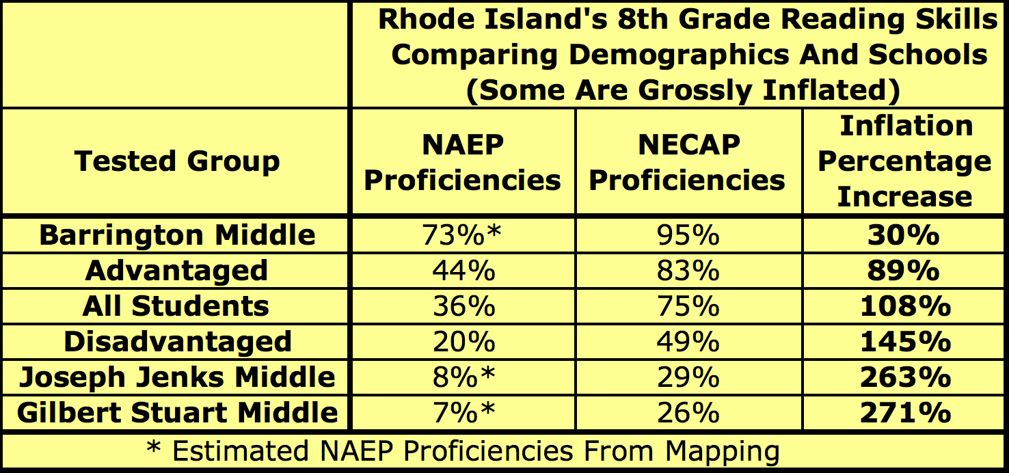

A similar picture emerges for the other reading and mathematics tests.

Who among the political class and government officials are willing to fix this mess? After discounting the complicit, the cowardly, and the ignorant among them, there are very few voices willing to speak out. Is anyone there to fight this battle? And what should be done?

Stakeholders interested in re-establishing the integrity of student assessments could make efforts in several broad areas:

- Use the political process to convince legislators, the Governor, and the Board of Regents to revamp the Rhode Island Department of Education’s (RIDE) assessment policies with the goal of eliminating the inflation. But our own efforts to begin a discussion with policy-making officials have gone nowhere.

- Act politically to establish an independent and politically neutral board to implement and operate the assessment systems- much the way Massachusetts had done with its MCAS tests. This might remove the structural conflicts of interest inherent in RIDE’s current arrangement where “looking good” is an important political motivation. The drawback here is that what politicians have established they can also abolish or corrupt- as we now see transpiring in Massachusetts where the formerly independent Board of Elementary and Secondary Education has been emasculated, with the MCAS soon to follow.

- Use a non-governmental private association to create and operate the assessment regime- the relevant example here being perhaps the way accountants take examinations to earn the CPA certification.

- Parents can simply use private education companies to have their children tested.

